**Target group**

As all the other social platforms, this social awareness website will be used all over the world for the users to share different information on different subjects that are challenging specific users. This website is intended to be utilized by virtually all categories of people apart from the minors.

**Use case diagram**

A use case diagram shows all the possible interactions that all the users in the system are involved in. It indicates all the possible users of the system together with the actions that they perform in the system. The figure below shows a use case diagram for the social awareness website.

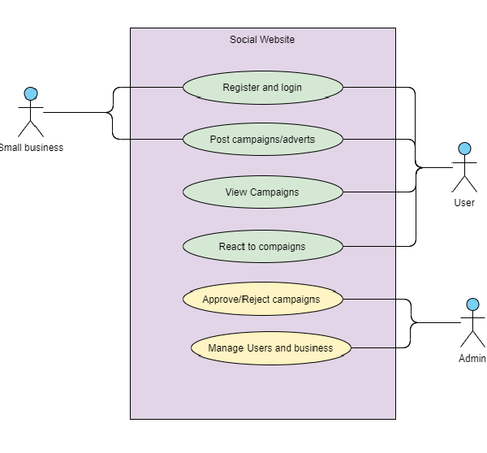

**Data flow diagram**

This a diagrammatic representation of the flow of information within an information system. It shows all the data inputs, entities, data stores and all the processes that act on the stored data. The figure below shows a data flow diagram for the social awareness website.

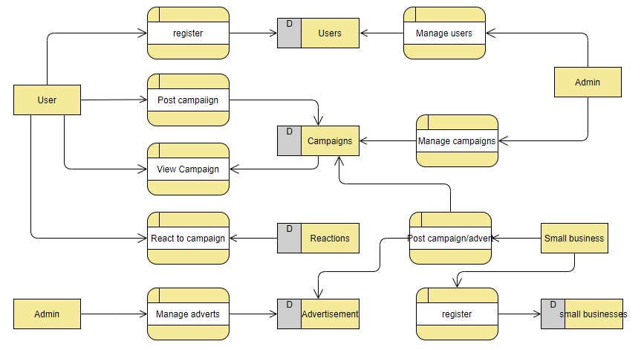

**Class diagram**

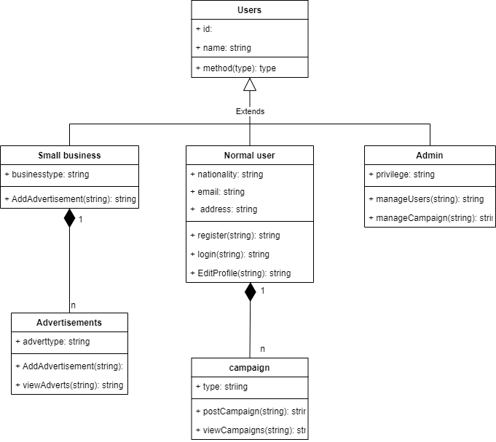

**Sequence diagram**

This is a diagram that depicts all the interactions that take place in the system but arranges in a time sequential manner. It shows the objects involved in the system and the sequence of messages exchanged between the objects that are needed to carry out the functionality of system. The figure below shows a sequence diagram for the social awareness website.

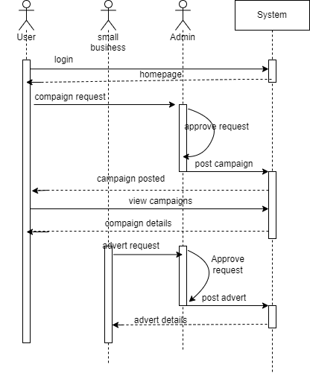

**Storyboard**

A Storyboard is a diagrammatic representation that uses visual tools to plan out each shot of a scene or sequence. All the scenes that occur in the social awareness website are represented in the storyboard below.

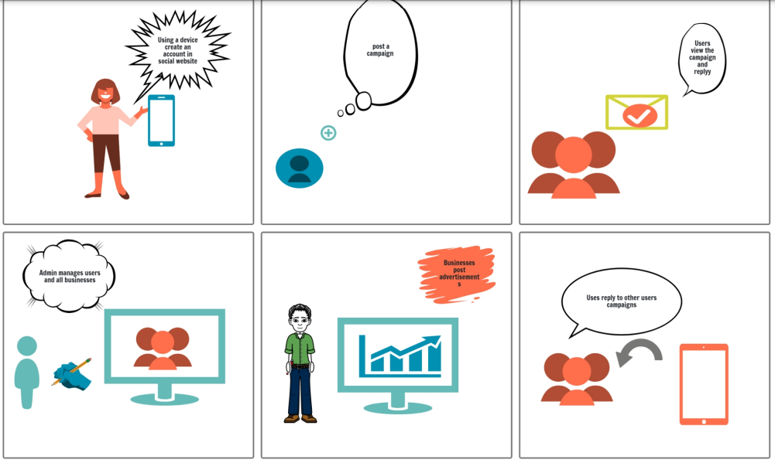

**Wireframes**

Login page

|  |  |  |  |  |  |  |
| --- | --- | --- | --- | --- | --- | --- |
| |  | | --- | | Navigation bar |  |  |  |  |  | | --- | --- | --- | --- | | **Login**  Username:   |  | | --- | |  |   Password:   |  | | --- | |  |  |  | | --- | | Login | |  |  | | --- | | Footer | |

Sign up page

|  |  |  |  |  |  |  |  |  |
| --- | --- | --- | --- | --- | --- | --- | --- | --- |
| |  | | --- | | Navigation bar |  |  |  |  |  |  |  | | --- | --- | --- | --- | --- | --- | | **Register**  Username:   |  | | --- | |  |   Email:   |  | | --- | |  |   Password:   |  | | --- | |  |   Confirm password:   |  | | --- | |  |  |  | | --- | | Login | |  |  | | --- | | Footer | |

Home page

|  |  |  |  |  |  |
| --- | --- | --- | --- | --- | --- |
| |  | | --- | | Navigation bar |  |  | | --- | | Campaign 1 |  |  | | --- | | Campaign 2 |  |  | | --- | | Campaign 3 |  |  | | --- | | Footer | |

**Entity relationship Diagram**

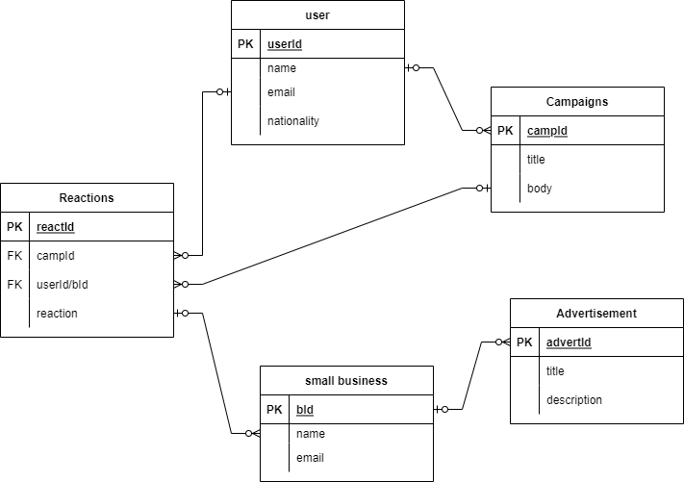

**Test cases**

|  |  |  |  |
| --- | --- | --- | --- |
| **Test case id** | **Test case name** | **Expected result** | **Actual result** |
| 1 | Register functionality | The page should display all the fields and all the data entered I the field should be inserted into the database after submitting the form. All errors should be handed appropriately. | The register form is displayed and the form successfully saves data into the database on submit. |
| 2 | Login functionality | The page should show a form where users enter their username and password. And afterwards redirected to the homepage. | The login form successfully logs in a user into the system |
| 3 | Logout functionality | This involves a button that ends the user’s current session on the system | The logout button successfully logs out a user from the system |

**Web design standards.**

A website should meet all the usability standards that can easily accommodate all the users. A good design should ensure that the website is consistent, responsive, accessible, navigable and very simple to use. As a result, the choice of the colors, fonts and layout determines to a great extent the usability of these designs. The design uses a light background without too much colors that would hinder usability. All the pages in the website are white and the font used is sans-serif black. The footer has a dark blue background and the font color is white. The website implements a simple layout with a top navigation bar, body and the footer. This layout has been implemented in all the pages in order to ensure consistency.

**Screenshots of running prototype**

**Logout functionality**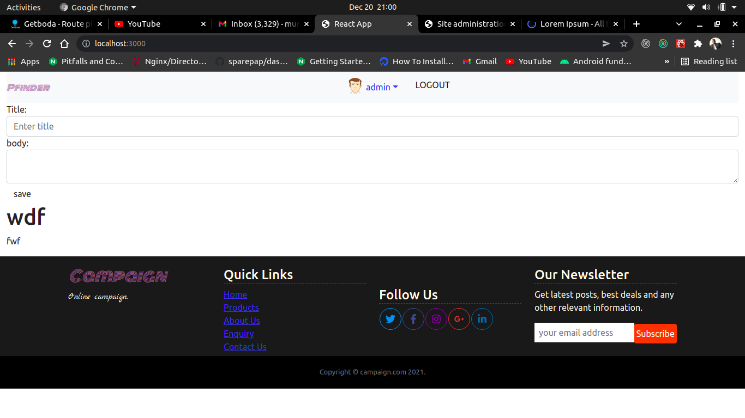

**Login**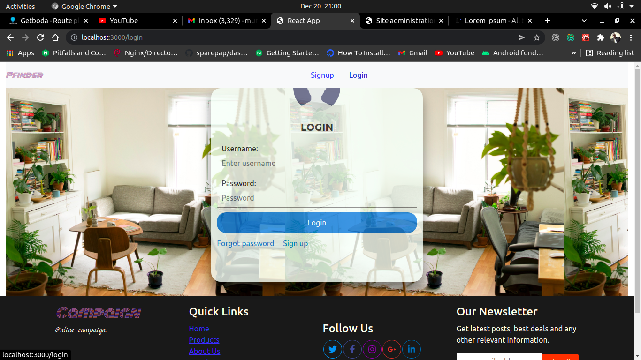

**Registration of new account**

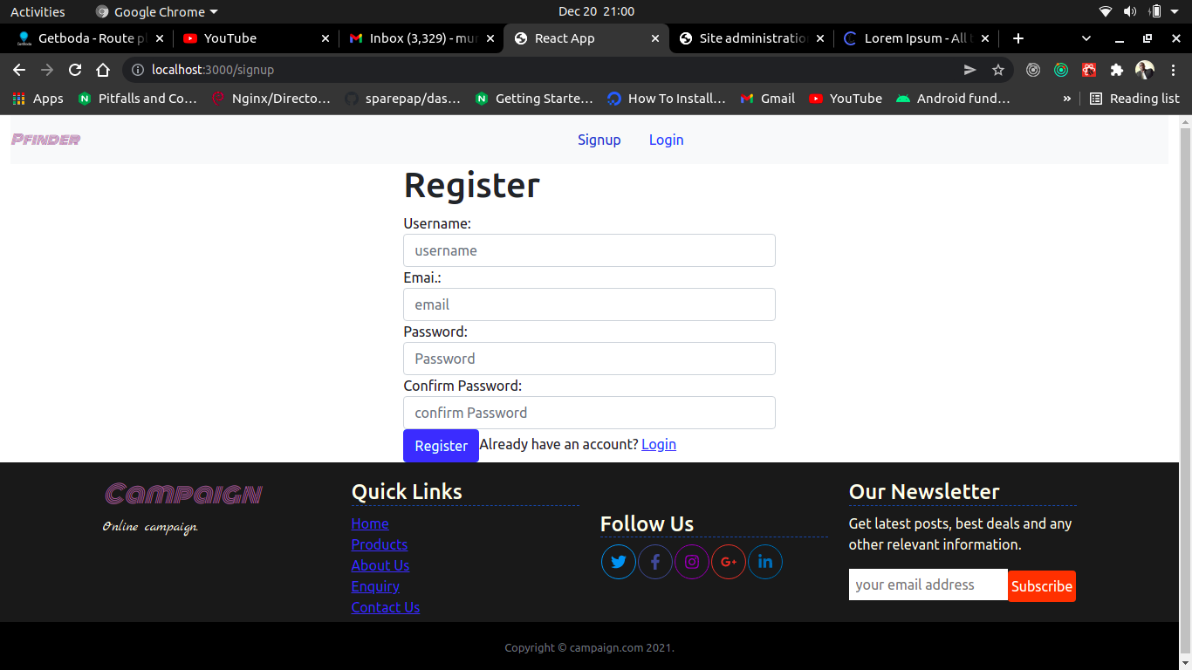

**Homepage with campaigns**

